A Polymorphic Arts Project: “Open-Venice: Rethinking Crisis”

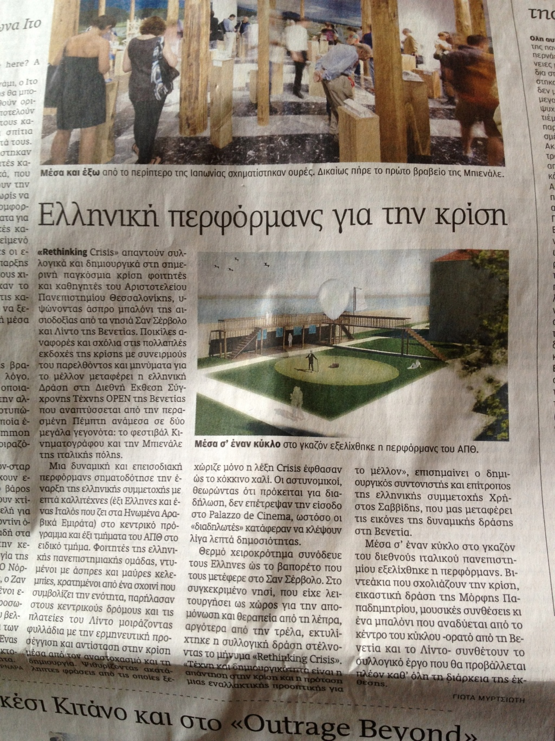

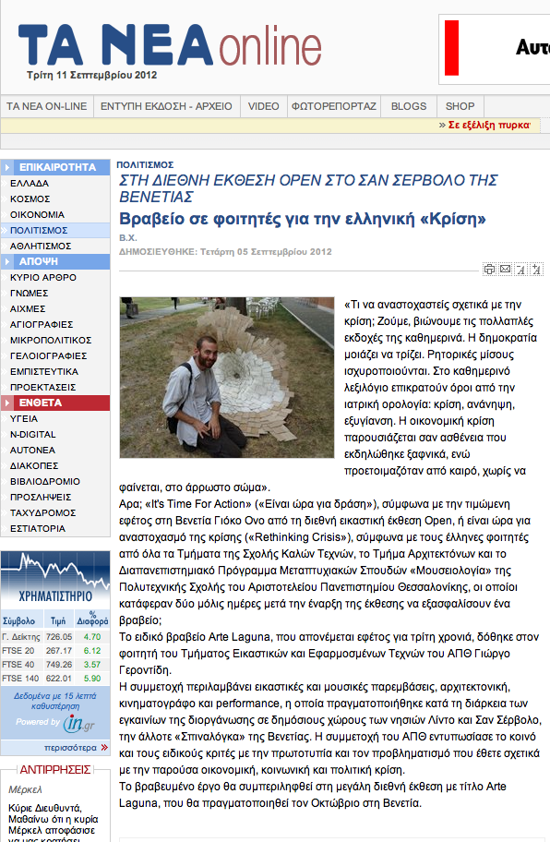

- It is a collaborative project that includes music, sound, film, theater, architecture and visual art interventions which, departing from the financial crisis in Greece and the wider crisis in Europe and modern society, critically address the concepts of rejection and incarceration, miasma and catharsis. The analogy is inspired by the location, the San Servolo island just in the middle, between Venice and Lido islands, which in the past had functioned, among others, as a place for the isolation and treatment for Hansen’s disease and later on madness, meaning as a place for the isolation of the infected and of the organically and socially ill. It can also be seen as an allegorical reference to the Greece of yesterday and that of today. From the past of madness, from the past of comedy and tragedy, to the present of rethinking and finally to the hope, to the desire of an escape in the future. Our comment is YES to Rethinking Crisis when “Don’t Think” and “Don’t Act” dominate. Finally, the strength is hiding in the society that dares to doubt and question its own certainties. All the students from those different schools along with their teachers collaboratively worked upon the subject, based on texts that were distributed by post-graduate students of museology and on discussions that took place among all the participants.
- 2) Are you having conversations with other artists with these themes and how they impact on your work (e.g. social media, or at exhibitions where you have had a chance to meet other artists, through the project itself etc.)
- This collective initiative, with the expressed support of the rector and the vice-rectors of the Aristotle University Thessaloniki, will also be presented in Thessaloniki, where it will function as an ongoing platform for similar projects related to the current crisis, which is judged not only as a financial one but also as one having a political, social and ideological basis and which refers to the whole Europe as well. With the support of the deCrisis small group of professors of the University being in collaboration with free lance arts managers we shall also be in close contact with the Mayor of Thessaloniki, giving creative answers to environmental and social problems of the city related more the city’s identity, hilenio@rect.auth.grstory and multicultural present. We are trying to be ready along with other creative young forces outside the university for the celebration of the year 2014 during which Thessaloniki has been nominated as the European Youth Capital. For the moment we are looking forward to the forthcoming workshop with students from the Institute Hyperwerk - Academy of Art & in Basel on “Creativity against the Crisis”, which is going to take place in Thessaloniki this September.
3) Do you have plans to continue producing work inspired by the euro crisis themes.
- Inspiration cannot be planned, but living in those hard times of crisis there is no way to escape from thinking of what the crisis is creating every day or create without the crisis in mind. Our insistence on creativity is our strength and our effort for serious and in depth thinking will make the difference.
- Students and professors of the common project named “Rethinking Crisis”
